San Francisco/San Mateo
Cursillo Secretariat
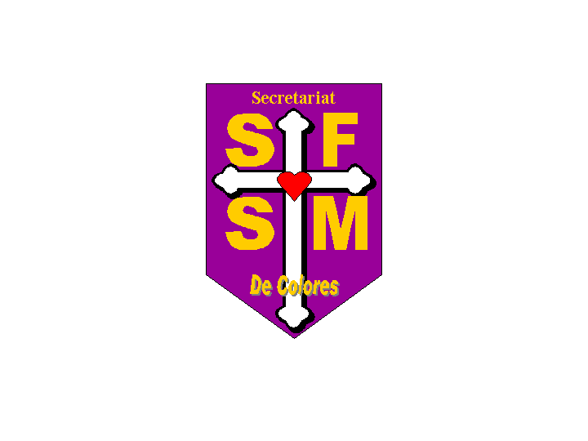

“Pass It On”

A Simple Approach to Stewardship
Within the Cursillo Community

Table of Contents

Cursillo and Stewardship 3
Purpose: 3
History: 3
Methods: 3
Introducing the Stewardship Plan (Rooster Boosters) 3
Presentations 4
Before the weekend 4
Initial Presentation 4
Team Presentation 4
During the weekend 4
After the weekend 4
“Pass It On” 4
Content 4
Mood 5
Delivery 5
Additional Items 5
Sample 6

Cursillo and Stewardship

Purpose:
Cursillo is a volunteer, not for profit organization and, as such, depends on the generosity of its members. Cursillo is an offering of love, time, talents and treasures. These offerings come in many different forms and combinations, but they are required for the movement to continue the fantastic success we have seen over the past 40 years.

History:
While at St. Benedict’s, a Cursillo was never complete without a talk from Fr. Rollie Jones. This was referred to as the “Sermon on the Amount”. Many people were moved by his ability to make the seemingly obvious so visible to everyone. His manner and mysticism made this a very enjoyable presentation for most Cursillistas.
The move to St. Thomas More began a new era. Not only was there a new facility, but also Fr. Jones was not able to provide those talks and, as a result, they faded into the memory of those who were fortunate enough to have heard them.
Now that we have moved from St. Thomas More there is an increased effort placed on bringing back the talk of Fr. Jones. Although no one can replace the man, another must take his place in instructing the candidates about how stewardship applies to the Cursillo movement.
As a result of the potentially negative reaction to the title “Sermon on the Amount”, the title of the presentation was changed to “Pass It On”. This simply asks the candidate to take what they have been given and “Pass It On”.

Methods:
Money obviously springs to mind when stewardship is mentioned, and it is the continued giving of many Cursillistas that has kept the movement alive and well. But there are many other forms of stewardship as well, such as volunteering, praying, witnessing, sponsorship and palanca, just to name a few. Any and all of these are valuable sources of stewardship and should be valued equally. It takes all of them to keep the movement going forward.

Introducing the Stewardship Plan (Rooster Boosters)
It is suggested that a representative of the secretariat meet with the core team, at their initial meeting, to explain the need for stewardship and the details of this plan. Providing a vehicle for communications is important in the early stages of formation so that no surprises or misunderstandings occur during this process or the subsequent weekend.

The representative should be available to present the information to the entire team, if asked.

We are all asked to be good stewards. God has given us so many gifts and we should be willing to share those with others. Happy and blessed is the one who gives in the name of the Lord. The importance of this cannot be stressed enough.

It is very important that the focus of stewardship be on the giving of all our gifts, time, talent and treasure and not just an appeal for money.

Applications, along with self-addressed envelopes, should be placed in each 4th Day packet, whether the talk is given or not. This will allow the candidate to participate if they wish.

Presentations

Before the weekend

Initial Presentation
The initial presentation should be made to the rector/a during their meeting with the secretariat. This will allow understanding of the need for the presentation and will allow the rector/a to tailor the presentation to the needs of the team.

Team Presentation
A presentation of the plan and guidelines should be made to the team at their first meeting. This sets the expectation and allows team members to fully understand the purpose and process of providing the talk during the weekend. Here, again, any fine-tuning of the process can be requested.
The talk itself should be presented to the team during the overnight. The speaker should solicit feedback and carefully consider modifying the talk to reflect those comments.

During the weekend
The “Pass It On” presentation could be presented on Sunday of the weekend, after lunch and before the final rollo. The exact time will be determined by the core team of the weekend.

After the weekend
If the talk is given during the weekend, a follow-up presentation should be provided at the team’s Ultreya. This will allow everyone another opportunity to consider entering into stewardship with the Cursillo movement. If not, this would be an excellent time to present the talk.
A representative of the secretariat could be present with detailed information about the Rooster Booster program, if requested. The materials could also be supplied to a representative of the teams participating in the Ultreya.

“Pass It On”

Content
The “Pass It On” presentation should talk about stewardship and the need for all Christians to be good stewards. It should contain bible passages on the subject of stewardship. There should be examples of the various forms of stewardship and how each person’s gifts are equally valuable.
An invitation should be made to each Cursillista present to join in the community of Christ and the fellowship of Cursillo. “Make a friend, be a friend, bring that friend to Christ”.
Issue a challenge to each Cursillista to begin 4th day with action. Let them know that it is OK to begin now and explain the blessings to be received by giving of one’s self.

Mood
This is a very serious talk and should be presented as such. Allowing everyone the opportunity to get seated and comfortable in his or her seats would be highly advisable.

Delivery
Presentation is critical. It is important not to loose the audience by repeatedly mentioning money. It is important that the speaker convey the importance of the talk and the resulting actions that should occur once the audience receives it.

Additional Items
The speaker should have copies of the Rooster Booster enrollment forms, envelopes addressed to the SF/SM Secretariat and a box in which items can be placed. This box should be left for the candidates and/or team members to deposit any forms they wish.

Sample
This is a sample of a “Pass It On” presentation and is only to be used as a guideline. Each speaker should make an effort to “make it their own” by adding personal touches.
“Pass It On”

This afternoon you will come to the end of your three-day journey, so perhaps it is fitting to ask if any changes have occurred since you arrived here. As I look around this room, it certainly has changed. I see evidence covering the walls of lots of love pouring in from the outside community, as well as your posters from Friday, caricatures of your own thoughts and feelings.

More significant though are the changes in each of us that will be used to change our environments as we continue this walk of faith. Remember the Rollo “Being Christ In Our Environment”? There was a message as to how we should move from this safe, wonderful place, back into our everyday lives. A message of how we can be AS CHRIST in our environment.

Cursillo has made an enormous change in my life. I was a regular, active member of my church and was a good husband, father and citizen in my community, but something just seemed to be missing. What was missing was the unconditional love of a large group of individuals who simply loved me for who I was at that moment, God’s love. Well, Cursillo certainly changed all of that. It has shown me how important it is to be guided by, and show, my feelings and thoughts as well. It has taught me to love everyone I meet unconditionally, with my whole heart and to see the face of Christ in everyone. Since my Cursillo, back in 1998, life has been far more joyous than ever before, and feedback tells me that I, in turn, have made others feel better as well.

Each team member, in his or her own way, has contributed energy toward making this one of the most love filled weekends possible, and each of you has responded in your own way to complete the picture of an ideal Christ community. This is truly what it is all about.

This afternoon you will walk away from this facility. If you’re like the overwhelming majority of candidates, however, you will never separate from the experience you have just been given. And, to the extent you change course toward a life centered in Christ, the world around you will become a far better place.

So, how did this weekend come to be? Cursillo is not a club, like Rotary or Kiwanis, with dues paying members. It is a not for profit movement based on the love and teachings of Jesus Christ, our Lord and Savior. This team was assembled and self-trained over the past year just for this weekend. It will never be re-assembled and the presentations and information you received will never be disseminated in quite the same way again. Much of what you have seen and eaten during this weekend was donated. It is palanca that has been provided by the Cursillo community, those who have come before you. It is a weekend that gives a gift of love to you from the gifts of love received from others.

Each of you has now been given a three-day holiday, complete with great meals, lodging and entertainment that is second to none, (well almost). You have received mail, now known as palanca, from many brothers and sisters in Christ who don’t know you, but love you just the way you are.

What is the value of a weekend like this? I wouldn’t venture a guess. Have you priced a life-changing weekend lately? What is the value of this Cursillo experience in your life? No one can place a price tag on that. All I can say it that my experience was priceless.

What we do ask is that you seriously consider how you can be a good steward of the love you have received this weekend and “Pass It On”. This is a real and effective way to be a light in the darkness. It is what keeps Cursillo moving forward and it is a fellowship in which we would like to invite you to share.

There are many ways to be a “Rooster Booster”. This is our program of stewardship, a program that will allow you to designate a pledge of time, talent and treasure to the support of our movement. A form has been placed in your 4th day packet and will help you to understand the program.

We have also provided a pre-addressed envelope. Think it over, and, if you wish to make a commitment to the work of our secretariat, put it in the envelope and mail it in during the next few days.
Remember that those who came before you have helped to produce this weekend. Now you have a chance to help unite others in the Holy Spirit through this incredible movement.
The Apostle Paul summed it up well in his first letter to the people of Corinth:
“There are different kinds of spiritual gifts, but the same Spirit gives them. There are different ways of serving, but the same Lord is served. There are different abilities to perform service, but the same God gives ability to everyone for their service. The Spirit’s presence is shown in some way to each one, for the good of all.”

God bless you, De Colores and Ultreya!

